**2022-2023**

**SECME National Engineering Design Student Competition Guidelines**

**Elementary School Division**

# Letter to our Competition Hosts

Dear SECME Educators and Competition Hosts:

The SECME National Office is excited to welcome you to the 2022-2023 SECME Competition year. This year’s competition theme is based on your school or Informal STEM Learning Environment (ISL) mascot or school motto. This document contains information for the SECME National Student Engineering Design Competition Guidelines, generally known as the “SECME National Guidelines.” The Elementary Division of the 2023 SECME National Student Engineering Design Competition Finals will be held virtually.

SECME competitions are a fantastic way for teachers to reinforce science, technology, engineering, and mathematics skills with exciting, engaging hands-on activities while challenging students to persevere and excel. SECME student competitions expose students to real-world applications in science, technology, engineering, and mathematics while generating interest and excitement about college and careers in STEM.

To our SECME Competition Hosts, in addition to hosting your SECME competition, in years past, many of you have provided technical assistance to schools and districts by way of SECME workshops for teachers to learn basic and necessary SECME competition skills to assist SECME students. The ability to provide these services continues to reside in this evolving new atmosphere. The SECME National Office is preparing to support by developing complementary competition training videos for all 2022-2023 registered schools.

To make this year’s competition fun and challenging, we added new engineering and artistic twists and turns to stir our future scientists’, engineers’, technologists,’ and mathematicians’ minds. Activities, deadlines, and SECME competitions at the local, district, state, and regional levels are at the discretion of the SECME Member University or Competition Host. We encourage participation at all levels and divisions (elementary, middle, and high school).

Thank you for your partnership and commitment to equity and excellence in STEM education. Have a wonderful and safe school year!

Sincerely,

Dr. Julaunica Tigner

Educational Outreach Manager

We welcome any corrections or any suggestions for improvement to our SECME National Guidelines. The feedback and comments we receive via email or telephone calls have supported the preparation of our annual guidelines. To provide feedback, please email [**julaunicatigner@ufl.edu**](mailto:julaunica.tigner@coe.gatech.edu)

Letter to our Competition Hosts 2

SECME Competition Information 5

SECME Important Deadlines 6

General Competition Information 7

Collaboration and Consent 7

New and Returning Features for 2022-2023 7

Registration of Winning Students and Student Teams 7

SECME Registration Information 8

SECME Eligibility Criteria 9

Required Competition Information 9

Register Students and Teams 9

SECME Competition Hosts Information 10

SECME National Competition Guidelines 11

Mousetrap Car 12

All Divisions - Construction and Operation 13

Construction and Design Requirements 13

Measurement of L, the Mouse Car’s Longest Dimension 15

Standard Mousetrap Diagram 16

Elementary School Division - Construction and Operation 17

In-Person Event - Calculation of Mousetrap Car Score 17

Example Calculation 18

Virtual Event - Calculation of Mousetrap Car Score 18

VEX IQ Robotics 19

Construction and Operation 20

VEX IQ Robotics Slapshot 21

Robot Hardware 21

2022-2023 Game 21

SECME Student Team Requirements 21

In-Person Event 21

Virtual Event 21

Water Bottle Rocket Design Competition 22

All Divisions - Construction and Operation 23

Regulations 23

Elementary School Division - Construction and Operation 24

In-Person Event - Calculation of Water Bottle Score 24

Virtual Event - Calculation of Water Bottle Rocket Score 24

Schematic Diagrams 25

Diagram 1: Parts of a WBR 25

Diagram 2: Nose Cone Diagram 26

Diagram 3: Fin Diagram 26

Patch Design Challenge 27

Example Patch Design 28

The Art of Engineering 29

The Art of Engineering Showcase 30

Essay and Vision Board Competition 31

Essay and Vision Board Introduction 32

Topics 32

Competition Requirements 32

Grades Pre-K – 2 32

Grades 3 – 5 33

Vision Board 34

Reporting Materials 35

Reporting Checklist 36

SECME Consent Form - Photographs or Videos 38

Saving Reports and Documents 39

SECME Coordinators 39

TIPS 39

Acceptable Fonts 40

Sample Cover Page 40

Essay and Vision Board 40

All Team Competitions 41

SECME Grievance Form 42

Frequently Asked Questions (FAQs) 43

# SECME Competition Information

|  |  |
| --- | --- |
| **Mousetrap Car** | **Water Bottle Rocket** |
| **Essay & Vision Board** | **VEX IQ Robotics** |

All SECME competitions:

* Are for individual SECME students and SECME student teams
* All SECME Competition Hosts should communicate with their participating schools and ISLs about their local arrangements
* Student teams may have one to three students on the team

SECME engineering design competitions are intended to challenge SECME student participants and develop essential skills for their futures as STEM professionals. Construction of vehicles, technical designs, technical and written reports, patch designs, PowerPoint presentations, essays, vision boards, and posters should be solely the work of the SECME student participants. Plagiarism is prohibited. Remember that **PLAGIARISM** is taking someone else’s work or ideas and passing them off as one’s own or using your old work and passing it off as new (self-plagiarism).

## SECME Important Deadlines

*The SECME National Office will publish announcements, changes, and updates on the SECME Website under the News tab. Additional details on the electronic submissions process are in the Reporting Checklist. Terms used throughout these* SECME National Guidelines *are on the Definitions and Explanations Page.*

**Monday, January 9, 2023** –Competing SECME schools must register with the SECME National Office

**Monday, January 30, 2023** – SECME coordinators must register students participating in their SECME programs with the [SECME National Office Database System](http://secme.secme.org/Logon.aspx).

**Friday, March 3, 2023** – Coordinators required to complete and submit the SECME participation survey

**Monday, March 13, 2023** – **Registration Opens**. Registration opens for all qualifying and non-qualifying competitions. All SECME competition hosts must register their SECME local, district, state, and regional first-place winners. **New!** SECME District and Regional Hosts must upload all required competition documents and videos. Click to view the [Reporting Checklist](https://drive.google.com/file/d/1dp0RNOdBm-tpVS63X_V_QR0xV-878Iuq/view?usp=sharing) section.

**Monday, April 3, 2023\*** – **Registration Closes**

*There is a deadline extension for the Texas Region

**Monday, April 10, 2023**

SECME Student Surveys are due for **ALL SECME students**. It is **REQUIRED** for all students. The links below are also available on our website at [www.secme.org.](https://secmeinc.wixsite.com/secme/surveys-reports)

[Grades Pre-K-2](https://docs.google.com/forms/d/e/1FAIpQLSdi2zdJJMA-rxnXYLa5RA6A4w9WYveUo7jSx-T2QYGO9nJ-tQ/viewform)

[Grades 3-5](https://docs.google.com/forms/d/e/1FAIpQLSf_ifcTiNtmyKXqQO_rdhDbz1qd4jLu0iGHP3MHr3lxbiuZ8Q/viewform)

**Monday, May 8, 2023** – Notification of Winners. SECME will post a listing of **all** winners on their website.

Click to download the [Important Deadlines](https://drive.google.com/file/d/1JXEdCrRgPIqCsMorjHDWaAPLgfIkybqJ/view?usp=sharing) sheet for your reference.

## General Competition Information

Please read the entirety of the 2022-2023 SECME National Student Engineering Design Competition Guidelines. Any alterations to these guidelines are prohibited. If you are a SECME competition host with local SECME competition guidelines, please keep the contents of the SECME National Guidelines separate from your local guidelines.

**All Elementary SECME Competitions are non-traveling.**

### Collaboration and Consent

To foster collaboration and a knowledge-sharing STEM community, all materials submitted to SECME will become the property of SECME and may be shared via the SECME website, marketing documents, presentations, etc. Materials include, but are not limited to, written and technical reports, engineering notebooks, pictures, technical drawings, etc. We have included a parent/guardian consent form to use said documents. The SECME Coordinator will provide this document to the parent/guardian of each 1st place winner of local, district, state, and regional winner. Click to download the SECME Consent Form - Photographs or Videos

### New and Returning Features for 2022-2023

* A standard tennis ball will be the passenger for the Mousetrap Car (MTC)
* The MTC andWater Bottle Rocket (WBR) builds have a $2.50 maximum budget – All divisions
* WBR calculation exercises submission in written and technical reports – All divisions
* Scoring adjustments for in-person and virtual competition methods
* Competition Hosts will **register** all first-place winning SECME students and student teams from their local, district, state, and regional competitions
* **New!** SECME District and Regional Hosts will upload all required competition documents and videos see [Reporting Checklist](https://drive.google.com/file/d/1dp0RNOdBm-tpVS63X_V_QR0xV-878Iuq/view?usp=sharing)
* An Art of Engineering Video Presentation (AOE) is required for all divisions and the following Team Competitions:MTC, WBR, and VEX IQ
* Patch Design theme aligned with SECME theme: your school or ISL mascot or school motto.
* A video demonstrating the competition vehicle: MTC, WBR, and VEX IQ in motion
* Video submission for Essay/Vision Board (optional)

### Registration of Winning Students and Student Teams

**Monday, January 30, 2023** SECME coordinators must register students participating in their SECME programs with the [SECME National Office Database System](http://secme.secme.org/Logon.aspx).

All 1st place winners at their local, district, state, or regional competition advance to SECME National Engineering Design Competition Finals. The SECME competition hosts must report all winners to the SECME National Office and upload their competition documents and videos via electronic registration. See [Reporting Checklist](https://drive.google.com/file/d/1dp0RNOdBm-tpVS63X_V_QR0xV-878Iuq/view?usp=sharing). Registration opens **Monday, March 13, 2023**, and closes **Monday, April 3, 2023\***. Complete the SECME Registration Information. *Deadline extension for the Texas Region.

## SECME Registration Information

Below is the information needed to register 1st place winners for qualifying and non-qualifying competitions. Registration opens **Monday, March 13, 2023**, and closes on **Monday, April 3, 2023**. A registration link will be sent with instructions to complete registration.

|  |  |  |
| --- | --- | --- |
| **SECME Coordinator & School Information** | | |
| SECME Coordinator (Last & First Name): | | SECME Coordinator Email: |
| SECME Coordinator Mobile Phone Number: | | Official School District & School Name:  School District:  School Name: |
| **SECME Student Team Information**  **(Required for each student on the SECME team)** | | |
| SECME Team Name:  VEX | | Student's (Last & First Name): |
| Grade Level: | Age: | Gender: |
| **Competition Results** | | |
| **Water Bottle Rocket**  Hangtime (s):  Score: | | **Mousetrap Car**  Longest Distance Travelled (cm):  Length (cm):  Time of Distance Travelled (s): |
| **VEX IQ Robotics Score** | | **Essay Score** |
| **Vision Board Score** | | |

## SECME Eligibility Criteria

**PLEASE READ CAREFULLY**

SECME Member Universities, Program Directors, and Coordinators are asked to distribute or reference these SECME National Guidelines to ***all*** educators, parents, business & industry partners, and graduate and undergraduate students who prepare students for this year’s competitions or serve as mentors or judges. They must fully understand the SECME National Guidelines and judging criteria for **each competition.**

1. All entries are expected to be neat, original, and **only completed by the SECME student**.
2. Elementary School SECME students will compete with other SECME students in their respective grade bands.
3. As identified in the SECME National Guidelines, first-place SECME local, district, state, or regional winning students or student teams advance to the 2022-2023 SECME National Student Competition Finals.

### Required Competition Information

Registration of your SECME program (school or ISL) and student data is an annual requirement to participate in SECME. Additionally, SECME Coordinators and students are to submit annual reports and surveys. SECME Coordinators **must** submit the following for your students to **compete** in SECME Competitions for the 2022-2023 school year:

1. All Competing schools/ISLs must register with the SECME National Office by **Monday, January 9, 2023.**
2. SECME Coordinators register all students participating in SECME National Engineering Design Competition Finals must be registered and updated in the [SECME National Office Database System](http://secme.secme.org/Logon.aspx) by **Monday, January 30, 2023**.

**Unregistered students will be ineligible to advance** to the SECME National Engineering Design Competition Finals.

1. SECME Coordinators, please follow your local, district, state, or SECME Competition Host’s procedures and dates for submitting all SECME-required competition documents, forms, and reports.
2. Student Surveys. **Allstudents participating in SECME must be complete the electronic student survey.** The Student Survey is required to advance to the SECME National Engineering Design Competition Finals and must be completed no later than **Monday, April 10, 2023.** Students **will be ineligible to advance** to the SECME National Engineering Design Competition Finals if they have not completed the SECME Student Survey.

### Register Students and Teams

All member universities, districts, and ISLs will receive an invitation to register their first-place winning students and student teams. If VEX IQ Robotics is not part of your local, district, state, or regional competition. In that case, Coordinators will have the opportunity to register their students competing in either of these competitions as these are “non-qualifying” competitions. Registration opens **Monday, March 13, 2023,** and closes **Monday, April 3, 2023**. Hard copy registrations and emails will not be accepted. If you have problems with the electronic registration, please contact the SECME National Office for assistance.

### SECME Competition Hosts Information

Upon notification of local, district, state, or regional winners, SECME Competition Hosts will be sent a link to upload all required competition documents, including the AOE video presentation, forms, reports, and photo/video permission slips/consent forms. Necessary documents are due on or before **Monday, April 10, 2023**.

Required competition documents **not uploaded** will receive a zero-point score for the designated category. The [Reporting Checklist](https://drive.google.com/file/d/1dp0RNOdBm-tpVS63X_V_QR0xV-878Iuq/view?usp=sharing) contains all of the reporting details. Upload competition documents electronically; email submissions are not accepted. Please contact the SECME National Office for assistance if you have problems with the electronic upload process.

# SECME National Competition Guidelines

# Mousetrap Car

(MTC)

Elementary School Division

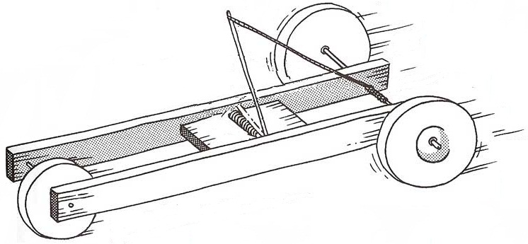

## All Divisions - Construction and Operation

Any team not adhering to the construction and operation guidelines will not be eligible to place.

**Elementary Mousetrap Car is a non-traveling student team competition.**

### Construction and Design Requirements

1. A **standard mousetrap** with dimensions of: length of 9.8 cm, width of 4.5 cm, and weight about 25 grams, **MUST** be used to construct the mousetrap car. NO PHYSICAL, CHEMICAL, MECHANICAL, OR THERMAL TREATMENT OF THE MOUSETRAP IS PERMITTED.
2. Standard mousetraps with **ONE SPRING** are **ALLOWED.**
3. The components of the mousetrap are a **wooden base. The other parts are mounted on the base:** **spring**, **bail**, **locking lever**, and **bait hook.** See Standard Mousetrap Diagram
4. The mousetrap’s “single” spring must be the sole source of power. You may **NOT** provide extra power to your car by using rubber bands, CO2 boosters, rollback wheels/gears, or other agents or elements.
5. In the car’s design and construction, the original mousetrap spring and wood base **MUST** remain intact. These two components may **NOT** be cut or altered in any way — mechanically, physically, chemically, or thermally. Only the locking lever and bait holder (and the staples that hold them on) may be removed from the base if desired. Teams may straighten the bail from its original bent configuration. It must remain a part of the completed car.
6. The spring must be visible and accessible to the judges for inspection.
7. The mousetrap car must have a minimum of **three wheels** and can be as long or short as desired if it meets **requirement #5** above.
8. Mousetrap cars are tested on a smooth flat surface. Distance will be measured from the front of the front wheel(s) at the starting point to the front of the front wheel(s) at the stopping point of travel, utilizing a straight line to connect the two points (**total displacement, not the path traveled**).
9. There will be two runs for each car. The best run is used for the final scoring of the mousetrap car’s performance.
10. The mousetrap car should reflect this year’s efforts by your SECME student teams. During SECME Competition, **ONLY** the SECME students on the same SECME student team can adjust or make alterations to their mousetrap car.
    1. If anyone other than the student teams is seen adjusting the mousetrap car, or there is evidence, the team will be disqualified and unable to compete.
    2. This includes but is not limited to SECME Coordinators/Coaches, Parents, etc.
11. Evidence of plagiarism or re-submission of previous years’ reports will result in a zero score.

The design requirement of this year’s SECME engineering design competition is for the SECME student team to design and build a vehicle solely powered by a single spring mousetrap with a maximum budget of $2.50 that can swiftly transport (or carry) a tennis ball with approximate weights and diameters of 57.7 grams and 66.9 mm (0.64 inches).

**The mousetrap car**

* Needs to carry a tennis ball with a weight of approximately 57.7 grams and a diameter of about 66.9 mm (0.64 inches)
* May NOT have glue, tape, or anything to affix the tennis ball to the mousetrap car
* May NOT wedge the tennis ball between the bait hook and the spring
* Should be designed to allow for the purposeful removal of the tennis ball with minimal effort so that the Judge can examine it
* Should transport the tennis ball (without losing it for the entire run)
* Should not exceed a budget of $2.50 in building materials (maximum budget)

Original receipts for all materials purchased must be included* (scanned) AND recorded on the SECME Mousetrap Car Material List. * (*If receipts are unavailable for new (not recycled) items, a link to the purchase website is sufficient to confirm the item cost.)*

* Do NOT include the cost of the basic mousetrap in your materials list
* If using recycled materials, documentation must show how these items were obtained
* Recycled materials are not included in the $2.50 maximum budget

**The tennis ball must remain in the mousetrap vehicle for the entire run of the mousetrap car to receive a qualifying score. A run is disqualified if the tennis ball falls out of the car.** If the tennis ball is dislodged due to a collision with an obstacle, the run is not disqualified. The run distance is measured to the point of collision - the front of the front wheel(s) at the starting point to the front of the front wheel(s) at the stopping point or the point of collision.

**A standard-size tennis ball with a diameter of 66.9 mm (0.64”) and 40 g will be given to the SECME student teams on the day of competition before their run at the SECME National Student Competition Finals.**

*The Mousetrap Car Materials List is required for the Technical Report Appendix for middle/high school teams and the Written Report for elementary school teams. If the Materials List is NOT submitted, the Cost (**C**) for the team’s score is double the highest cost (**CH**) in the competition formula.

### Measurement of L, the Mouse Car’s Longest Dimension

The length L is the longest dimension in the x, y, or z-axis. In other words, it could be the length, width, or height of the completed mousetrap car, which is the longest dimension.

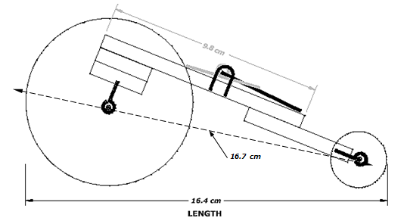

The mousetrap car’s **length L is the longest dimension in the car’s x, y, or z-axis** while the car is resting with the spring unwound. In other words, it could be the length, width, or height of the completed mousetrap car, which is the longest dimension. If the bail has been straightened and protrudes past the front or rear of the car, the measurement is taken from the end of the bail to the other end of the car.

**L (for this example) = 16.4 cm**

### Standard Mousetrap Diagram

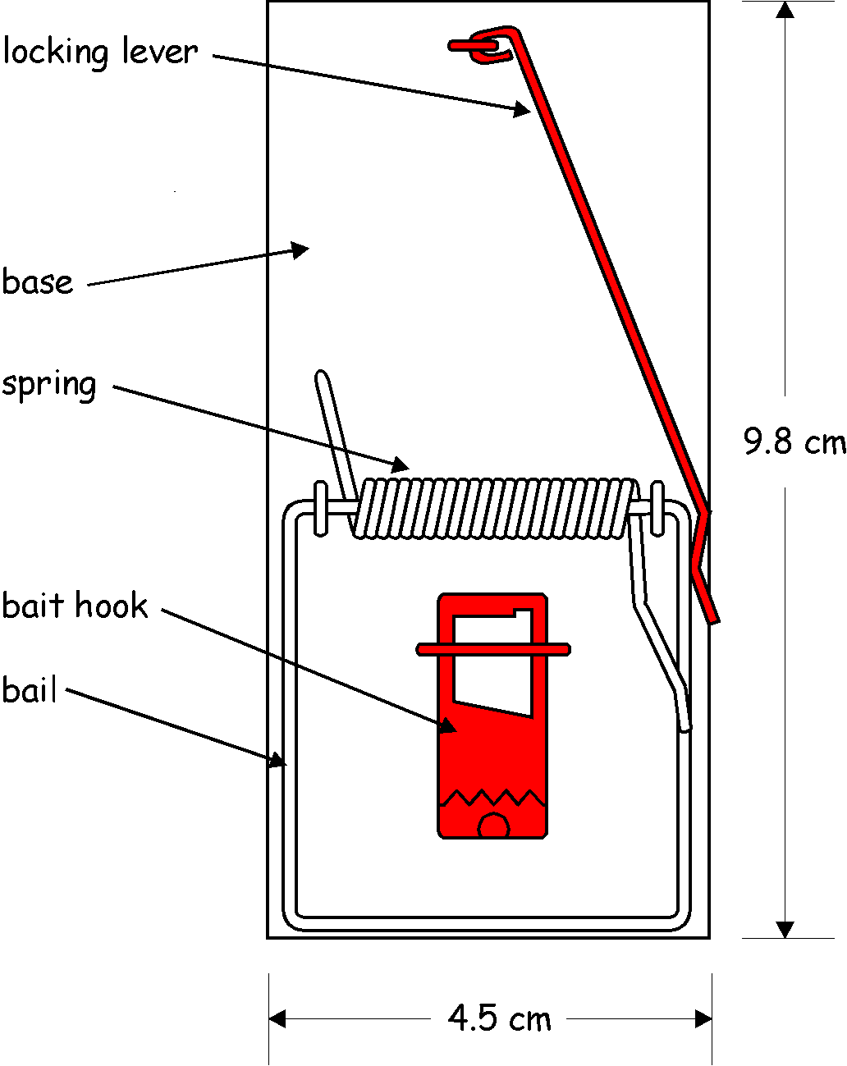

**NOTE: The red parts may be removed from the car.**

## Elementary School Division - Construction and Operation

The MTC Engineering Design Competition, Elementary School Division **requires participation in these two areas**:

1. Performance Run of the Mousetrap Car
2. Written Report on Mousetrap Car

### In-Person Event - Calculation of Mousetrap Car Score

The performance score for the Mousetrap car run is calculated using the following equation:

Where:

D is the distance the mousetrap car travels measured in centimeters (cm).

L is the longest length of the completed mousetrap car from any orientation on the x, y, and z-axis measured in centimeters (cm).

T is time measured from when the mousetrap car is released until the car has stopped, measured in seconds (s).

C**+** is the cost of the construction of the completed mousetrap car (based on the team’s MTC Materials List).*

CH is a constant 2.5 (the highest possible cost). **Therefore,** in the equation.

P is the mousetrap car performance run score.

where:

PH is the highest performance mousetrap car score on the day of the SECME Competition.

F is the final performance score to be combined with the score from the Written Report.

Distance is measured from the front of the front wheel(s) at the starting point to the front of the front wheel(s) at the stopping point of travel, utilizing a straight line to connect the two points.

The Mousetrap Car **MUST** travel a **MINIMUM** distance of **2 m (200 cm)** to qualify for the competition.

Suppose the mousetrap car stops due to hitting an object or wall. The distance is measured from the starting point to the point of impact.

*\*If the MTC Materials List is NOT submitted, the* ***Cost (C)*** *for the team’s score is calculated as double the* ***highest cost (CH)*** *in the competition formula.*

*+If the value of C is $0.00 (meaning that except for the mousetrap, your car is built entirely with recycled materials), then use $0.01 (one penny) for the value of C.* ***Therefore,***  *in the equation.*

### Example Calculation

The Final Score is based on the following two criteria*:

* Performance Score 50%
* Written Report 50%

### Virtual Event - Calculation of Mousetrap Car Score

Calculate the score when there is no physical competition - car run

For the virtual competition in the elementary school division, to calculate the performance score for your Mousetrap car run, use the following values:

The Final Score is based on the following two criteria*:

* Performance Score 50%
* Written Report 50%

**\*NOTE: The maximum elementary division mousetrap car final score is 100 pts.**

# VEX IQ Robotics

Elementary School Division

<https://www.vexrobotics.com/iq/competition/viqc-current-game>

## Construction and Operation

The VEX IQ Robotics Design System offers students an exciting platform for learning about areas rich with career opportunities spanning science, technology, engineering, and math (STEM). These are just a few of the many fields students can explore by creating with VEX IQ Robotics technology. Beyond science and engineering principles, a VEX IQ Robotics project encourages teamwork, leadership, and problem-solving among groups. It also allows educators to easily customize projects to meet the level of students’ abilities.

**Elementary VEX IQ Robotics is a non-traveling student team competition.**

Please follow the instructions below to participate in the SECME VEX IQ Robotics Competition.

1. **Team Registration:** You are encouraged to register your team with VEX IQ Robotics at [www.RobotEvents.com](http://www.robotevents.com/). Registration connects you to the system and gives you access to resources.
   1. Registration costs $100 for the first team and $50 for each additional team at the same school.
   2. Registration gets you access to the official VEX IQ Robotics Competitions and a welcome kit that includes:
      1. Sample Game Pieces
      2. Robot License Tags
      3. Robot Flags
      4. Other promotional items
   3. Teams **DO NOT** have to be registered with VEX to participate in “**SECME ONLY**”robotics events.
2. **Competition Format:** SECME will follow the VEX IQ Robotics “Game Rules” and may or may not include the following:
   1. Alliances
   2. Head-to-head
   3. Autonomous Period
   4. Robot Skills Challenge
   5. Programming Challenge
3. SECME VEX IQ Robotics are non-qualifying competitions. Your student team does not have to place first in your local, district, state, or regional competition to compete at the SECME National Competition level. In the absence of a SECME VEX IQ Robotics competition at your local, district, state, or regional competition, the Coordinator must notify the SECME National Office that they have a student team(s) that they would like to be registered. The SECME National Office will provide the designated links to upload all required documents.
4. **SECME Student Team Requirements:** VEX IQ Robotics is a non-qualifying SECME Competition. Student teams can be made up of one, two, or three students per team.

## VEX IQ Robotics Slapshot

<https://www.vexrobotics.com/vexiq/>

<https://www.vexrobotics.com/iq/competition/viqc-current-game>

### Robot Hardware

* If you already have a robot kit - reuse it.
  + We recommend getting a quote from your local reseller if you need VEX IQ Robotics parts. It costs you nothing extra but brings you their local support.
    - Visit <https://www.vexrobotics.com/how-to-order>to find a reseller in your area
    - or visit the VEX IQ Robotics website at [https://www.vexrobotics.com/.](https://www.vexrobotics.com/)
  + You can also contact the SECME National office to direct you to the support representative for your state.

### 2022-2023 Game

This year’s game is [Slapshot](https://www.youtube.com/watch?v=vF3I8FscrKo). With guidance from their SECME Coordinators, teachers, and mentors, students will build the most innovative robots possible and work together to obtain the most points possible. Students will learn many academic and life skills through participating in the VEX IQ Robotics Competition and their work within their team.

To access the official VEX IQ Robotics Slapshot competition resources, [click here.](https://www.vexrobotics.com.mx/vexiq/doctos/2022/2022-VIQC-GameManual2023.pdf) To see the VEX IQ Robotics Slapshot video, [click here.](https://www.youtube.com/watch?v=vF3I8FscrKo)

### SECME Student Team Requirements

VEX IQ Robotics is a non-qualifying SECME Competition. If your students compete in a virtual competition, student teams can be made up of one, two, or three students.

### In-Person Event

**The Final Score is based on the following criteria*:**

* Performance Score 50%
* Engineering Notebook 50%

### Virtual Event

**The Final Score is based on the following criteria*: (when there is no performance score)**

* Engineering Notebook 50%
* The Art of Engineering 50%

# Water Bottle Rocket Design Competition

(WBR)

Elementary School Division

## All Divisions - Construction and Operation

While promoting Space Propulsion Awareness, the Water Bottle Rocket Competition helps familiarize students with rocketry, design engineering, and manufacturing engineering principles. SECME students will **design and manufacture** a water bottle rocket using a two-liter bottle as the pressure vessel. Given specific launch criteria, the rocket must launch from the Water Bottle Rocket Launcher. Additionally, each SECME team will **create a patch design, written or technical report, PowerPoint presentation (middle/high school division), and technical drawing.**

We have added two new features for this competition year.

1. All divisions must complete and submit the WBR calculation exercises. These exercises are included in the written/technical report
2. Water Bottle Rocket (middle/high school) teams will now compete in the Art of Engineering competition segment. Teams must submit the AOE video presentation

**Calculation Exercises:** Grades Pre-K - 2 Grades 3-5

**The Mission**

The mission is to design a Water Bottle Rocket Vehicle capable of staying aloft for the longest time (measured in seconds).

### Regulations

1. The pressure vessel must be **ONE clear two-liter bottle** (i.e., **NO tinted bottles allowed** for use as a pressure vessel). See Diagram 1.
2. Water and air pressure is the sole source of propellant.

**Do not use the following materials to construct your rocket. They are dangerous and could harm the operator and bystanders at launch.**

* 1. **Metal**
  2. **Glass**
  3. **Hard plastics**
  4. **Spikes**
  5. **Antennas of any kind**
  6. **Rocks**

**NOTE: *USE OF THESE MATERIALS WILL AUTOMATICALLY DISQUALIFY THE SECME TEAM\***

1. Leave **7.5 cm** from the throat of the exit plane (bottom of the rocket) clear of any coverings (paint, markings, drawings, etc.). See Diagram 1.
2. The maximum total height of the rocket is **76 cm**; see Diagram 1.
3. The Nose-cone tip must have a minimum radius of **1.5 cm**; see Diagram 2.
4. Fins may extend to the throat exit plane; see Diagram 2.

**NOTE: No forward-swept types of fins are allowed to be used on the rocket.**

1. The bottle’s maximum fin width distance is **10 cm** (or **16.5 cm** from the center of the bottle axis). See Diagram 3.
2. Parachutes are **NOT** allowed to be used.

## Elementary School Division - Construction and Operation

**Elementary Water Bottle Rocket is a non-traveling student team competition.**

### In-Person Event - Calculation of Water Bottle Score

**NOTE:Each entry must pass a visual inspection and height requirement to be eligible to compete. Entries that fail inspection are given ONE opportunity to make modifications to pass inspection before the beginning of the water bottle rocket competition.**

An overall winner is determined by the following criteria (based on 100 pts):

* Final Hang Time of Rocket 40 %
* Patch Design 25 %
* Written Report 35 %

**Final Hangtime Score Calculation**

**Hangtime** is the time from when the rocket leaves the launch pad until it (or any part of it) reaches the ground or strikes an object. This measurement will be taken using a stopwatch by two or three (2-3) qualified judges. The average of the judges’ times will be used as the team’s hangtime.

**Max Hangtime** is themaximum hang time recorded during the SECME Competition.

The contest’s objective is for each SECME student team to launch a rocket-propelled by water and air and for it to stay aloft for the maximum amount of time (measured in seconds). The launch angle, which can be adjusted from approximately **90 degrees (90o),** will be kept the **SAME** for all rockets launching during a particular competition. Each rocket will be launched using **12 oz** water at **70 psi** of air pressure.

**NOTE:** The maximum final elementary Water Bottle Rocketry score is **100 pts**.

### Virtual Event - Calculation of Water Bottle Rocket Score

**There is no hangtime performance**

**The winner will be judged on the following criteria:** (based on 100 pts):

* Patch Design 25%
* The Art of Engineering 25%
* Written Report 50%

**The written report must include calculation exercises:**

Grades Pre-K-2

Grades 3-5

## Schematic Diagrams

### Diagram 1: Parts of a WBR

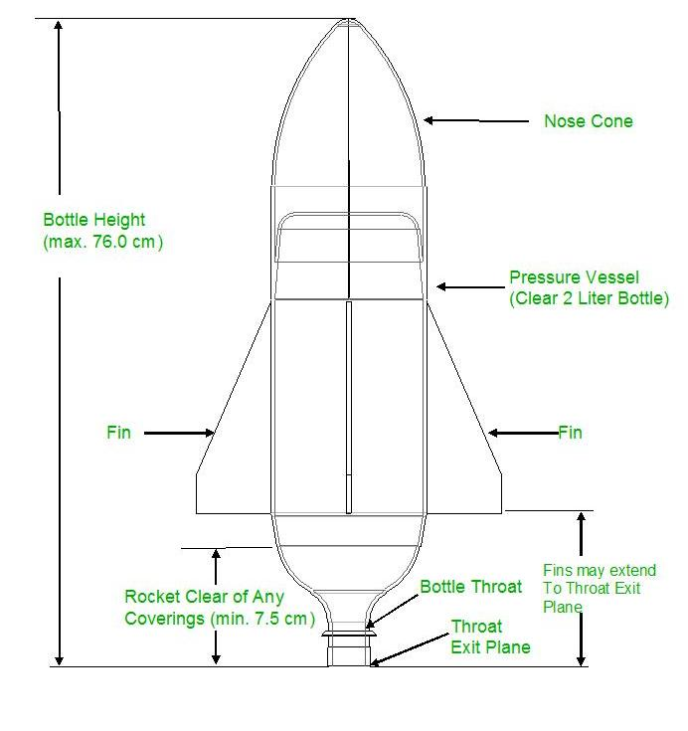

### Diagram 2: Nose Cone Diagram

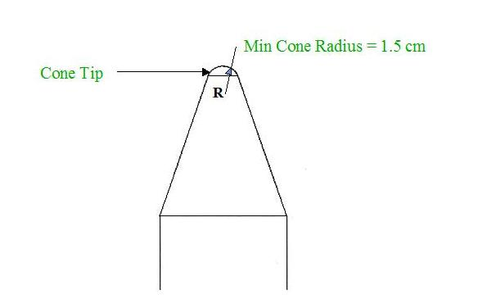

### Diagram 3: Fin Diagram

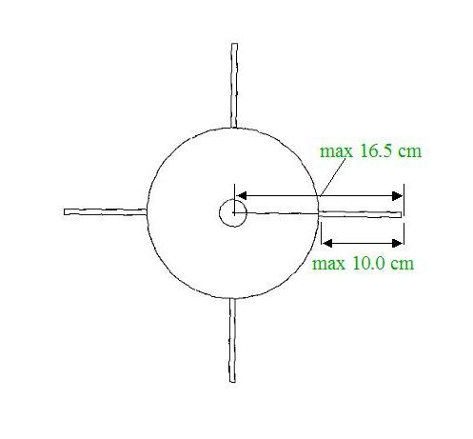

## Patch Design Challenge

**What is a patch? A patch is a creative display that reflects the dedication and mission of the SECME student team.**

**This symbolic picture must comply with the following patch design challenge:**

1. Each SECME student team is required to submit a completed patch design.
   1. Check with your local, district, state, and regional SECME Competition Host for local submission deadlines
2. Before the launch, an operating rocket and patch design must be submitted to compete on the day of the competition.
3. Each entry must be prepared and submitted by the SECME student team members participating in the Water Bottle Rocket Design Student Competition.
4. Patch designs must be submitted on a 13” 13” poster board.
5. All patch entries must follow the SECME competition theme: your school or ISL mascot or school motto.
6. A short (less than one page) explanation of the patch’s symbols must be included on the back of the patch design (**Refer to the example on the next page).** The following information should be included on the back:
   1. Competition (ex. SECME Water Bottle Rocket)
   2. Division (ex. Elementary School Division)
   3. SECME Team name
   4. Official School Name
   5. Official School District Name
   6. SECME Student Members’ Names and Grade Levels
   7. Student Coordinator’s/Teacher’s Name
7. All SECME student teams participating in the SECME Water Bottle Rocket Student Competition must display their patch before their rocket launch.
8. Patch Design must be the original work of the SECME student team. It must be hand-made (not computer-generated) and age-appropriate.
9. Teams may only use ink pens, pencils, colored pencils, crayons, markers, or paint.

**NOTE: Inappropriate patch designs will be removed from the competition. The SECME team will receive a score of zero for patch design.**

**The patch design will be judged on the following criteria:**

1. Paper Size Requirement 13” x 13” poster board
2. SECME Theme: your school or ISL mascot or school motto.
3. Appearance
4. Creativity
5. Explanation of Patch – Less than a one-page explanation of your patch

### Example Patch Design

P938#y1

**Example Explanation of Patch**

The propelled rocket represents the school system, supported by educators and students, following a path towards excellence. The radiant five 8-point stars symbolize the enrichment of Science, Engineering, Communication, and Mathematics, whereas the seven 4-point stars represent the seven Universities that founded SECME. The three distinct contrails STEMing behind the rocket symbolize the support offered by SECME, Universities, and Industry partners. The ring before the rocket depicts a student’s path through the SECME program, returning full circle to support the program’s efforts. As we have entered the new millennium, the sun over the horizon symbolizes the induction of the new Water bottle rocket Design Competition into the SECME Programs. Accuracy, the contest’s focus, represents the target created by the outer ring, deep space, and the earth. The border is supported on the left and right by the water and compressed air symbols; the fluids used to propel the rockets.

# The Art of Engineering

(AOE)

## The Art of Engineering Showcase

What is the Art of Engineering (AOE)? AOE is an opportunity for SECME student teams to showcase and discuss the design approach used for their car, rocket, or robot. **The AOE competition only takes place at National Competition Finals.**

**New!** The AOE video presentation is a virtual only competition.

1. This video presentation showcases the **ART** in the SECME student team engineering design of their car, rocket, or robot.
2. Each SECME student team will submit a five to seven-minute video on their car, rocket, or robot from a creative, innovative, and artistic perspective.

In the video, teams will:

* Introduce their team and themselves
* Introduce their final design
* Walk through their design process
  + Brainstorming design ideas – initial sketches and ideas
  + Prototype Versions – at least two versions
    - What each prototype looked like (image or drawing)
    - What changes were made from each version
  + Final Design
    - Technical drawing and image
    - What changes were made from the last prototype
    - Why this design is your final design

Every student team member must contribute to a piece of the video to get all possible points. Be interactive and engaging in your presentation.

**Dress Code.** The Art of Engineering showcase’s required dress code is a polo shirt (in your school colors) and khaki pants.

# Essay and Vision Board Competition

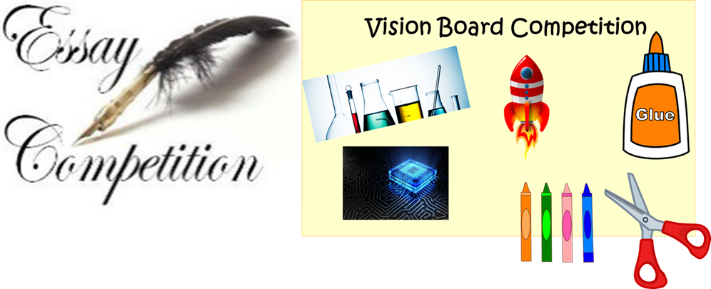

## Essay and Vision Board Introduction

SECME’s essay and vision board competitions are written and illustrative representations of the of the topics below. **Essays can be written around Topics 1-4. All vision boards are created around Topic 1.** All essay/vision board submissions will require a cover page.

* Grades Pre-K-2 - students will only create vision boards around Topic 1.
* Grades 3-5 - students can choose any topic for the essay portion of the competition. Students will create vision boards around Topic 1.

### Topics

1. How has participation in SECME helped you to discover my STEM dream job?
2. How has the COVID-19 pandemic shown the importance of STEM?
3. Environmental issues
   1. Forest Fires
   2. Global Warming
4. How is Artificial Intelligence (AI) beneficial to technology? What are the limitations of AI technologies in STEM fields?

Topics are open to all grade levels; however, some topics may require more critical thinking, explanations, and details, depending on the grade level.

### Competition Requirements

Follow allinstructions. Each essay and vision board entry must be prepared and submitted by an individual SECME student.

When choosing topics 2-4, answer the questions:

1. How does or how should STEM impact these global or environmental issues?
2. How do you see yourself contributing to the solution to these global or environmental issues? We encourage you to use your imagination.
3. How do you see yourself contributing to the use of AI technologies in STEM fields?

The vision board can be hand drawn or created using a computer program. For boards created by hand, teams can use materials such as magazine clippings, newspaper clippings, crayons, markers, colored pencils, colored pens, or paint. Clip art or electronic visual graphics are allowed when designing on a computer. Your vision board must be one page, and it can either be positioned in portrait or landscape.

### Grades Pre-K – 2

**Using topic 1**, Create your vision board on paper. Next, working with your SECME Coordinator or parent/guardian, record a four-minute maximum video message explaining your vision board and how participation in SECME has helped you to choose that career path.

Submission of your vision board must include the following:

1. Required cover page
2. Vision Board drawing is one page in length and can be positioned either in portrait or landscape
3. Four-minute (max) video explaining your vision board

### Grades 3 – 5

**Choose a topic from the topic list (1-4) to write your essay.**

**Using Topic 1,** Create your vision board. Write a paragraph or two describing your vision board.

Writing is critical, but it is a learned skill, and some students perfect it sooner than others. As an optional addition to writing, you may record a four-minute video explaining your vision board!

Submission of the essay/vision board must include the following:

1. Required cover page
2. The essay should contain 500 – 1,000 words
3. Write a one-paragraph description of your vision board (note that your description should be included in your essay, not on the vision board page)
4. Vision Board drawing is one page in length and can be positioned either in portrait or landscape
5. Four-minute (max) video explaining your vision board (optional)

### Vision Board

This vision board is a visualization of your future STEM career. Using art, create a vision board that depicts your future career path and expresses your hopes and dreams in **S**cience, **T**echnology, **E**ngineering, and **M**athematics.

SECME students can use clip art, electronic visual graphics, magazine clippings, newspaper clippings, crayons, markers, colored pencils, colored pens, and paint.

**Grades Pre-K-2** are required to submit a video explanation of their vision board no longer than 4 minutes.

**Grades 3-12** are required to submit a one-paragraph description of their vision board. They can submit an optional video explanation of their vision board no longer than 4 minutes.

SECME students put their vision board on an 8.5” 11” white paper. The page layout (or the paper orientation) can be either landscape or portrait.

**The Vision Board will be judged on the following criteria:**

1. Paper Size Requirement (8.5” 11”)
2. Harmony between the essay and vision board
3. Appearance, Effort, Creativity, Originality
4. Video explanation of the Vision Board (Pre-K-2 grades)
5. One paragraph explanation of the Vision Board (3-12 grades)
6. Video explanation of the Vision Board (3-12) - optional

# Reporting Materials

## Reporting Checklist

**Required for Competition**

The SECME competition hosts must report all winners to the SECME National Office and upload their competition documents and videos via electronic registration. Registration opens **Monday, March 13, 2023**, and closes **Monday, April 3, 2023\***. Complete the SECME Registration Information. *Deadline extension for the Texas Region.

Reports not submitted will result in a zero score for that section. Except for videos, **ALL** work must be converted to a PDF document before submission.

|  |  |  |  |
| --- | --- | --- | --- |
| **ELEMENTARY SCHOOL DIVISION** | | | |
| **MTC** | **WBR** | | **VEX IQ** |
| * Written report (includes MTC materials list and handwritten calculations) * Photos of car * Video of the car in motion * AOE video presentation * Consent Forms * Team Photo | * Written report (includes calculation exercises) * Patch * Photos of rocket * Video of the rocket in motion * AOE video presentation * Consent Forms * Team Photo | | * Engineering Notebook * Photos of robot * Video of the robot in motion * AOE video presentation * Consent Forms * Team Photo |
| **ESSAYS/VISION BOARD** | | | |
| **Grades Pre-K-2** | | **Grades 3-5** | |
| * Vision Board * Video vision board explanation – 4 min. max * Consent Form * Student Photo | | * Essay * Vision Board * Vision Board Explanation (1-paragraph) * Video vision board explanation (optional) 4 min. max * Consent Form * Student Photo | |
| **ADDITIONAL SUBMISSIONS DUE** | | | |
| SECME Student Surveys  **Allstudents participating in SECME must be complete the electronic student survey.** The Student Survey is required to advance to the SECME National Engineering Design Competition Finals and must be completed no later than **Monday, April 10, 2023.** Students **will be ineligible to advance** to the SECME National Engineering Design Competition Finals if they have not completed the SECME Student Survey. | | | |
| **EXPLANATIONS** | | | |
| *Vision Board Video Explanations*  *Video explanations should be a maximum of four (4) minutes.*  *MTC and WBR*  *Technical and Written reports must have the materials list page included in the report. Reports should also include, where applicable, their handwritten calculations (MTC) and 1 set per team of the calculation exercises (WBR).*  *Photos of vehicle*  *MTC photos should be taken from 5 angles: top and bottom view; left, right, and back views.*  *WBR photos should be taken from 4 angles: top and bottom view; left and right-side views.*  *VEX photos should be from 4 angles: top and bottom view; left and right-side views.*  *Consent Forms*  *Consent forms are required for* ***each*** *student and* ***each*** *student on the team.*  *AOE Video Presentations should be five to seven minutes maximum.*  *A video demonstrating the movement and functionality of the SECME student team’s vehicle, and the demonstration video should not be longer than 2-minutes.* | | | |

## SECME Consent Form - Photographs or Videos

SECME, Inc. recognizes the need to ensure all young people’s welfare and safety by participating in any activity associated with our organization.

Photographs/videos of your child participating in SECME activities and competitions are often sent to our National Office. The SECME National Office will not permit photographs, videos, or other images of your child/ren to be posted as listed below without the consent of you, the parent/caregiver. As your child will participate in the SECME program throughout the 2022-2023 school year, we would like your consent to capture and post photographs or videos of your child during the SECME competitions. These images may likely be used as:

* A record of the activity or the event
* In a written evaluation report of the activity or event
* Publicity material for further activities or events on leaflets/websites/magazines or other forms of social media
* Future grant applications

We would be grateful if you would return this form to your child’s SECME teacher/Coordinator. They will forward the form to our office.

I consent to / do not consent to

(type/print name of parent/caregiver)

SECME, Inc. using photographs or videos of

Name of child

Official Name of SECME School/ISL

Name of SECME Teacher/Coordinator

Signature of parent/caregiver Date

## Saving Reports and Documents

Essay/Vision Boards, Vision Board Videos, Picture Books, Posters, Written, and Technical Reports, PowerPoint Presentations, Engineering Notebooks, and AOE Videos

### SECME Coordinators

Please follow the dates and methods for submission in the SECME National Guidelines and the dates and methods required by your local, district, state, or regional SECME Competition Host.

### TIPS

1. All reports, essays, vision boards, picture books, posters, and forms must be submitted in PDF format.
2. To save an MS Word document as a PDF file, click the “File” button, choose “Save As,” name the file in the “Filename” field, change the “Save as type” to PDF, and then click the “Save” button.
3. Keep the documents saved in several locations or on multiple computers so that all team members and the school coordinator can access them at any time.
4. Make sure that all copies stay updated with the latest changes and edits.
5. Plan time to work on the documents from the beginning of the project. **Do not wait until the last minute.**
6. Make sure all required sections are included.
7. Spell-check/grammar-check.
8. Carefully re-read the entire completed document.
9. Upon finding mistakes:
   1. Make changes/edits.
   2. Re-save the updated document.
   3. Repeat these suggestions until satisfaction is achieved.
10. Video files can be in the following formats: MP3/MP4.

**New!** Upon notification of local, district, state, or regional winners, SECME Competition Hosts will be sent a link to upload all required competition documents, including the AOE video presentation, forms, reports, and photo/video permission slips/consent forms. Necessary documents are due on or before **Monday, April 10, 2023**.

Required competition documents **not uploaded** will receive a zero-point score for the designated category. The [Reporting Checklist](https://drive.google.com/file/d/1dp0RNOdBm-tpVS63X_V_QR0xV-878Iuq/view?usp=sharing) contains all of the reporting details. Upload competition documents electronically; email submissions are not accepted. Please contact the SECME National Office for assistance if you have problems with the electronic upload process.

## Acceptable Fonts

|  |  |
| --- | --- |
| Arial | This is an example of a 12-point Arial font. |
| Calibri | This is an example of a 12-point Calibri font. |
| Courier New | This is an example of a 12-point Courier New font. |
| Times New Roman | This is an example of a 12-point Times New Roman font. |

## Sample Cover Page

### Essay and Vision Board

Title: *Topic*

Student Name (First and Last Name)

Student Grade

Official District Name

Official School Name

City, State

SECME School Coordinator’s Name or Teacher’s First and Last Name

Coordinator/Teacher email address

### All Team Competitions

Title: (Example) SECME Engineering Design Competition: Mousetrap Car Written Report

Division: (Example) Elementary School Division

Team Name: Mouseketeers

Student 1 Name (First and Last Name)

Student Grade

Student Email

Student 2 Name (First and Last Name)

Student Grade

Student Email

Student 3 Name (First and Last Name)

Student Grade

Student Email

Official District Name

Official School Name

City, State

SECME School Coordinator’s Name or Teacher’s First and Last Name

Coordinator/Teacher email address

## SECME Grievance Form

[Link to the SECME Grievance Form](https://forms.gle/U4q4gSnznZsCw9yL7)

for Review by Judges

**SECME Competition Host**

**SECME Competition Event Division**

**SECME Team Name**

**Official School Name**

**Official School District Name**

**SECME School Coordinator/Teacher Leader**

**SECME School Coordinator Preferred Email**

**SECME School Coordinator Telephone**

**Competition Rule or Procedure in Question**

**Specific Concern**

**Submitted by: (Name) Date**

**Note:** [Click here](https://forms.gle/U4q4gSnznZsCw9yL7) for the SECME Grievance form for Review by Judges for SECME National Student Competition Finals.

**(Use the back page or 2nd sheet if more space is needed to document fully)**

# Frequently Asked Questions (FAQs)

*If you have any questions or need help in these specific areas, please contact:*

* Engineering Design (Mousetrap Car): Contact the Member University engineering representative who sponsors your Regional/State competition.
* Engineering Design (Water Bottle Rocketry): Contact the Member University engineering representative who sponsors your Regional/State competition.
* VEX V5/VEX IQ Robotics:Contact the SECME National Office ● [secme@eng.ufl.edu](mailto:secme@eng.ufl.edu)
* Essay/Vision Board, Picture Book, and Poster Competitions: Contact the SECME National Office ● [secme@eng.ufl.edu](mailto:secme@eng.ufl.edu)

1. **What if my winning school is not listed in the drop-down option?**

Only registered schools for the 2022-2023 school year will populate. Please select “not listed” and type in the Official School Name if the school’s name is not listed. We will follow up with that school.

1. **We are a registered school but do not have a Regional Competition scheduled for this year. Can we participate in the SECME National Competition activities?**

Yes! Please contact Dr. Julaunica Tigner, SECME Outreach Coordinator, at [julaunicatigner@ufl.edu](mailto:julaunicatigner@ufl.edu) for competition details.

1. **Can we purchase mousetrap kits from the SECME National Office?**

*No,* *SECME no longer sells mousetrap kits. Instead, SECME has adopted and encouraged scratch-build designs to foster more creativity and innovation. SECME Coordinators/ISLs can purchase mousetrap car kits at the following websites:*

1. [Pitsco](https://www.pitsco.com/SearchAll/?keywords=mousetrap_car_kit&type=0)
2. [Midwest Supply Company](https://www.midwesttechnology.com/midwest-products-mousetrap-racer-kits-12/)
3. [DOC FIZZIX](https://www.docfizzix.com/)
4. [Kelvin Educational](https://kelvin.com/search.php?search_query=mousetrap+car+kit)
5. [Sciencekit.com](https://sciencekitstore.com/mousetrap-car/)
6. **Where can we purchase bulk two-liter plastic bottles?**

[Pitsco](https://www.pitsco.com/Two-Liter-Plastic-Bottle-30-Pack) or your local recycling facility

1. **Where can we purchase the tennis balls?** Please find one suggested supplier below:

[Amazon (Pack of 3 Tennis Balls)-$6.99 as of 08/31/2022](https://www.amazon.com/Wilson-Minions-Stage-Tennis-Balls/dp/B08SMLGTFS/ref=sr_1_3?crid=1JD4VRLXCI4EA&keywords=tennis%2Bballs&qid=1661976476&refinements=p_89%3AWILSON&rnid=2528832011&s=sporting-goods&sprefix=tennis%2Caps%2C263&sr=1-3&th=1)

1. **Where can we purchase the engineering paper?** Please find one suggested supplier below:

[ArtSupply.Com (10-sheets for $18.26 as of 08/31/2022)](https://www.artsupply.com/Clearprint-Vellum-17-X-22-10-Sheet-Pack_p_45604.html)

1. **How does my SECME team determine the cost of 3D printing?** For 3D printing, the SECME student team evaluates the cost of the material used to make the part for their vehicle.

**Example**: Polylactic acid (PLA) pellets can be purchased for the price of $10.00 per 1 kg. If the SECME student team only used 1 g, the following calculation they would need to do to determine the cost of their 3D component:

The following is a link to how much 3D materials will cost in 2020:

<https://all3dp.com/2/how-much-do-3d-printer-materials-cost/>

1. **How does my SECME team log their purchases on their material list?**

**Example**: Balloons were purchased for $10.99 for 100 balloons. If the SECME student team only used two balloons, the following will be the calculation they would need to do to determine the cost:

An example of how to fill out the material list.

|  |  |  |  |
| --- | --- | --- | --- |
| **Part Name** | **Description** | **Purchase/Recycled** | **Cost** |
| Balloons | $10.99 for 100 balloons | **Purchased ☒**    **Recycled ☐** | *$0.22 (2 balloons)* |

1. **Local, District, State, or Regional SECME Competition Concerns and Complaints**

*Please complete and submit the SECME Competition Grievance Form to the local, district, state, or regional SECME Competition Host. The local, district, state, or regional SECME Competition Host should handle all grievances at the local, district, state, or regional levels.*

*Note: Please follow any additional instructions or procedures your local, district, state, or regional SECME Competition Host implements.*